**Question 1**

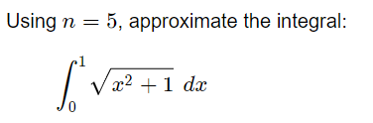

**Question 2**

Solve the system linear of equations

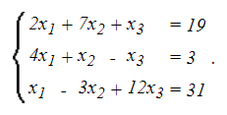

by the Jacobi/Gauss Seidel method